Create table given below: Salesperson and Customer

Salesperson

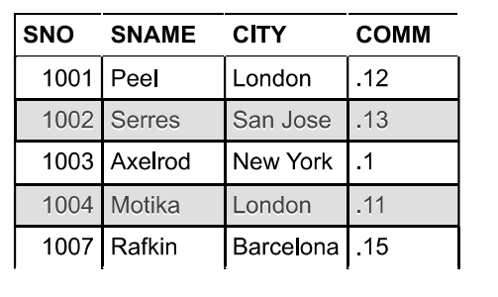

Customer

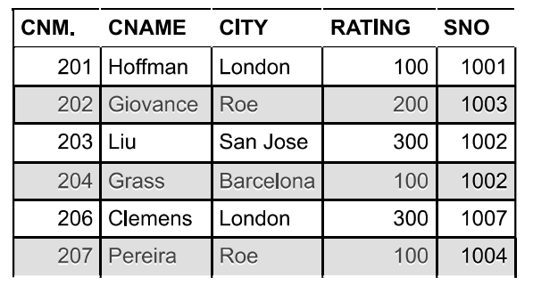

b) Names and cities of all salespeople in London with commission above 0.12

ans.

SELECT `SNAME`,`CITY`

FROM `SALESPERSON`

WHERE `CITY` = 'London' AND `COMM` > 0.12

c) All salespeople either in Barcelona or in London

ANS;

SELECT \*

FROM salesperson

WHERE CITY = 'Barcelona' OR CITY = 'London';

d) All salespeople with commission between 0.10 and 0.12. (Boundary values

should be excluded).

ans.

SELECT `SNAME`FROM salseperson GROUP BY COMM HAVING (COMM) BETWEEN .10 AND .12

e) All customers excluding those with rating <= 100 unless they are located in

Rome

SELECT \*

FROM customer

WHERE RATING> 100 OR (RATING <= 100 AND City = 'Roe');